CURRICULUM VITAE

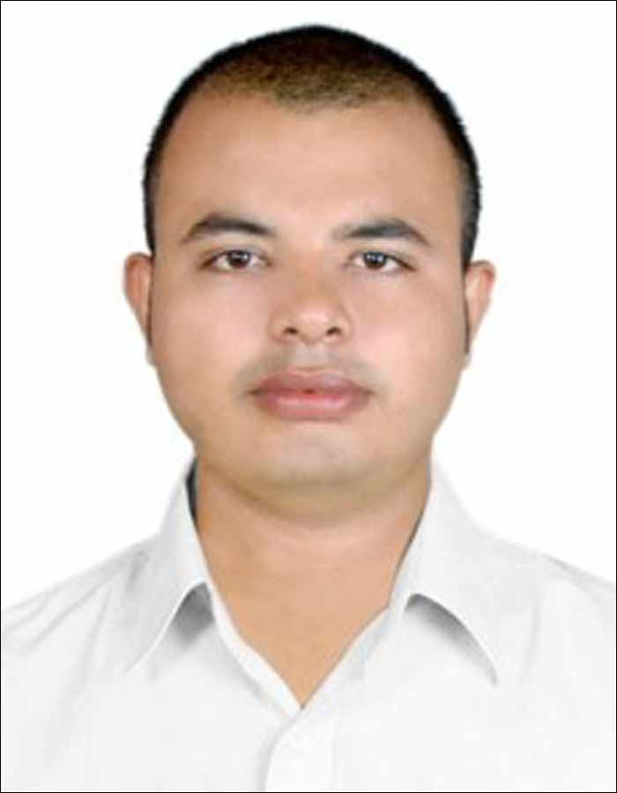

Please affix a
Passport size
photo here

Arun Kumar Khamari
Mobile No.: +91 9861602066
E-mail id: arunkhamari18@gmail.com

Career Objective: To utilize my skills in the industry that offers me a professional growth through my sincere efforts and knowledge.

Educational Qualification:-
Examination | School /College | Board/University | Year of Passing |  | CGPA/Percentage Secured
M.Tech(Comp Sci and Engg.) | VSSUT, Burla | Sambalpur, Orissa | 2018 |  | 74%
B.Tech (Comp Sci and Engg.) | Orissa Engg.College,  Bhubaneswar | University of Technology, Orissa. | 2014 |  | 63.1%
12th | Balangi Mohavidyalaya, Sunhat | CHSE | 2006 |  | 62.10%
10th | Kendriya Vidyalaya, Balasore, Odisha | CBSE | 2004 |  | 66.20%

Projects Undergone:-

Title of the project – Online Rainbow Coloring for Special Classes of graph
Duration – June 2017 to June 2018 [1 year]
Team Size – 1
Description – Rainbow coloring is a special case of edge coloring, where there must be at least one path between every distinct pair of vertices that consists of different color edges. Here, we may use the same color for the adjacent edges of a graph representing two different paths from a single vertex. In online rainbow coloring, we have no prior knowledge about the vertices and edges of the graph, in fact the edges are available one by one. We have to color an edge as soon as it arrives and before the arrival of the next edge. We cannot revoke the coloring decision once it is made. According to our knowledge, there is no study of online rainbow coloring for graphs. In this paper, we make a first attempt to propose an online algorithm named Least Recently Used Color (LRUC) for online rainbow coloring. We analyse the performance of LRUC through competitive analysis. We show that LRUC is optimal for line graph, tree and star graph. For 1-cyclic graph, LRUC is shown to be (2-2/n) competitive, where n ≥ 4. We obtain the competitive ratios of (n-1)/n and n -1 for wheel and complete graphs respectively, where n is the number of vertices.

CURRENT POSITION:

M.tech in the Department of Computer Science and Engineering at Veer Surendra Sai University of Technology, Burla, 768018, Odisha from 10/06/2018.
(Work Completed)

- Broad Area Of Research: Graph Theory & Algorithms
- Specific Domain: Online Algorithms
- Research Problem: Online Rainbow coloring for special classes of graph

Computer skills:-
- Languages : C, C++, PHP

Achievements and Accomplishments:-

- All India Camel Color contest (2002).
- IT scholarship for an IT program at NIIT (2008).
- Android Application Development Workshop (2012).
- Cloud Computing Workshop (2016).
- Internet of Things devices and Sensor Network Workshop (2016).
- Short term course Latex (2017).
- Professional Skills Workshop (2017).
- Student Organizer on Professional Skill (2017).
- Fundamental Algorithms Design and Analysis Workshop (2017).
- Soft Computing Techniques for Engineering Problem (2018).
- Cloud Computing Workshop (2018).
- Participation certification on ADMA Conference and Graph Theory Day (2018).
- Presented certificate on International Conference on Discrete Mathematics and its Applications to Network Science (2018).

Hobbies and Interests:-

- Movies
- Football
- Chess

Strengths:-

- A quick learner
- Hard worker
- Good sense of humor

Personal Information:-

- Father’s Name : Mr. Birendra Nath Khamari
- Mother’s Name : Mrs. Mandakini Khamari
- Date of Birth : 26th April, 1986
- Gender : Male
- Language skills : English, Hindi, Oriya
- Permanent Address : Arun Kumar Khamari,
Vill- Kamaragadia,
Post- Putura,
PS- Single,
Dist- Balasore,
Odisha , Pin no-756081

- Address for Correspondence

Declaration:-
I hereby declare that all the above-mentioned information provided by me is true to the best of my knowledge.

Date :
Place : Arun Kumar Khamari

